Chapter 5, Solution 70.

The output of amplifier A is

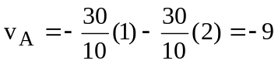

The output of amplifier B is

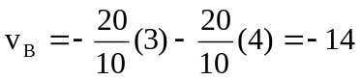

40 kΩ
10 kΩ
−
+
20 kΩ
60 kΩ
b
a
v_{B}
v_{A}
v_{o}

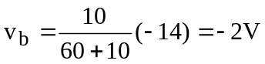

At node a, 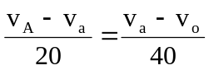

But v_{a} = v_{b} = -2V, 2(-9+2) = -2-v_{o}

Therefore, v_{o} = 12V

